Question 38:

CODE:

%{

#include <stdio.h>

%}

%%

([0-2][0-9]|3[0-1])[-/](0[1-9]|1[0-2])[-/](19[0-9]{2}|20[0-2][0-9]) {

printf("Valid DOB: %s\n", yytext);

}

.|\n { /\* Ignore other characters \*/ }

%%

int main() {

yylex();

return 0;

}

int yywrap() {

return 1;

}

OUTPUT:

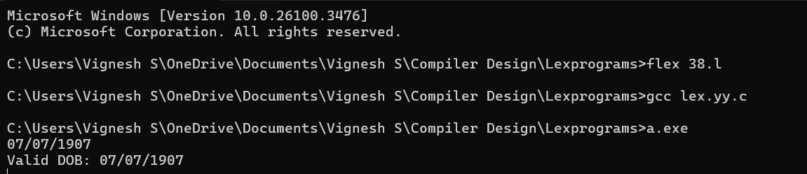

Question 39:

CODE:

%{

#include <stdio.h>

%}

DIGIT [0-9]+

%%

{DIGIT} { printf("Number: %s\n", yytext); }

"+" { printf("Operator: Addition (+)\n"); }

"-" { printf("Operator: Subtraction (-)\n"); }

"\*" { printf("Operator: Multiplication (\*)\n"); }

"/" { printf("Operator: Division (/)\n"); }

"%" { printf("Operator: Modulus (%)\n"); }

.|\n { /\* Ignore other characters \*/ }

%%

int main() {

yylex();

return 0;

}

int yywrap() {

return 1;

}

OUTPUT:

